KABARAK UNIVERSITY



SCHOOL OF SCIENCE, ENGINEERING AND TECHNOLOGY

INTE 424: IT PROJECT II

REAL-TIME WATER MONITORING SYSTEM

PRESENTED BY:

GEORGETTE KOKI-INTE/MG/1483/09/20

FINAL PROJECT SUBMITTED TO THE DEPARTMENT OF COMPUTER SCIENCE AND INFORMATION TECHNOLOGY (UNDER THE SCHOOL OF SCIENCE, ENGINEERING AND TECHNOLOGY) IN PARTIAL FULFILMENT DEGREE IN INFORMATION TECHNOLOGY

MARCH 2024

**ACKNOWLDEGEMENT**

There are many people that supported completion of this proposal with encouragement, assistance and references. Special thanks to the university supervisor Mr. Cleophas Mochoge for guiding me through development of this final project. I wish to acknowledge the panelist from computer sciences department for guiding me during the process of defending this proposal.

I would like to also express gratitude to my loving parents for their prayers and financial support.

I thank my fellow colleagues for sharing with me ideas that helped in the development of this proposal. Honor and thanks to the almighty God for His mercy, guidance and strength during the whole period of the project.

**DEDICATION**

This project is dedicated to my family and friends for their unwavering support that has been instrumental in shaping my academic journey. I dedicate this to them with heartfelt gratitude and love. I also dedicate it to Kabarak University for the support even in imparting skills and knowledge needed in this project work.

**DECLARATION**

This concept was original with no prior submissions to other universities for a degree.

Georgette Koki Mulinge

INTE/MG/1483/09/20

Signature ……………………… Date………………………….

With my permission as the project supervisor, this project has been put

Up for review.

Mr. Cleophas Mochoge

Signature ………………………… Date…………………………

**ABSTRACT**

The need for effective and efficient monitoring, evaluation and control of water quality in residential area is more demanding in the era of urbanization, pollution and population growth. Ensuring safe water supply of drinking water is a big challenge for modern civilization. Traditional methods that relied on collecting water samples, testing and analysis in water laboratories are not only costly but also lack capability for real-time data capture and analysis of information to relevant persons for making timely and informed decisions. Thus, a real time water quality monitoring system prototype is developed for water quality monitoring in schools is presented. The development and creation began by evaluation of the environment around us including availability of network coverage at the place of operation. The system consists of an onboard processor node (MCU)- (a device that provides a versatile and cost-effective approach to connect devices to the internet) that preprocesses acquired data and transfer to the cloud (Firebase) for determining the water quality together with water quality measurement sensors. It detects water temperature and total dissolved solids in real-time and disseminates the information in graphical and tabular formats to relevant stakeholders. Different research sources showed that the system had great prospect and could be used to operate in real world environment for optimum control and protection of water relevant and timely information to facilitate quick action that users might need to take.

***Keywords****: Node (MCU), Real-Time, Water Quality, Cost Effective*

**Table Of Contents**

CHAPTER ONE: INTRODUCTION 8

INTRODUCTION 8

1.1 BACKROUND OF THE STUDY 8

1.2 PROBLEM STATEMENT 9

1.3 OBJECTIVES 9

1.3.1 GENERAL OBJECTIVE 9

1.3.2 SPECIFIC OBJECTIVES 9

1.4 JUSTIFICATION OF THE STUDY 10

1.5 SCOPE OF THE STUDY 10

1.6 LIMITATIONS OF THE STUDY 11

CHAPTER TWO: LITERATURE REVIEW 12

2.0 INTRODUCTION 12

2.1 REVIEW OF RELATED LITERATURE 12

2.2 Related works: 12

2.2.1 The SCADA system 13

2.2.2 Physical Parameters Testing Methods 13

2.2.3 Inductive Coupled Plasma 15

2.2.4 Chemical Parameters Testing Methods 15

2.2.5. Chromatography 16

2.2.6. Color Disc Comparator & Colorimeter Color 16

2.2.7. Atomic Absorption Spectrometer (AAS) 18

2.2.8 Microbiological Parameters Testing Methods 18

2.2.9. Most Probable Number (MPN) 19

2.2.10. Membrane Filtration 19

2.2.11. Spectroscopy Techniques 20

2.3 THEORETICAL FRAMEWORK 22

2.3.1 Sensors and Data Acquisition 22

2.3.2 IoT Connectivity 22

2.3.4 Data Transmission and Communication: 22

2.3.5 User Interface and Visualization: 22

2.4 CONCEPTUAL FRAMEWORK 23

2.5 IDENTIFICATION OF THE GAP 24

CHAPTER THREE: RESEARCH METHODOLOGY 25

3.0 INTRODUCTION 25

3.1 DESCRIPTION OF THE AREA OF STUDY AND POPULATION 25

3.2 HARDWARE ARCHITECTURE 25

3.2.1 Data transfer to cloud 26

3.2.2. End User Access 26

3.3 REFERENCES 26

3.4 APPENDICES 28

3.4.1 RESEARCH QUESTIONNAIRE 28

3.5 WORKPLAN 32

3.6 PROJEC BUDGET 33

3.7 DESIGN DIAGRAMS 34

3.7.1 CONTEXT DIAGRAM 34

3.7.2 DATAFLOW DIAGRAM 35

3.7.3 USE CASE DIAGRAM 36

CHAPTER FOUR: SYSTEM IMPLEMENTATION AND DEPLOYMENT 38

4.0 INTRODUCTION 38

4.1 SYSTEM DESCRIPTION 38

CHAPTER FIVE: CONCLUSION AND RECOMMENDATION 39

5.0 CONCLUSION 39

5.1 RECOMMENDATION 39

5.2 FUTURE IDEAS 39

# **CHAPTER ONE: INTRODUCTION**

## **INTRODUCTION**

This system integrated aims to use IoT technologies to provide continuous, accurate, and actionable insights into the quality of our water resources. By leveraging the capabilities of IoT devices, specifically Node MCU, this project aimed to transform the way we perceive, analyze, and safeguard our water ecosystems.

## **1.1 BACKROUND OF THE STUDY**

Over the past couple of years, maintaining pure supply of water to the people is getting more challenging day by day. In Kenya, especially in the big cities purification of water is done mainly by use of chemicals to clean river/ lake/dam water then supply to the people who reserve this water without even testing. Water sanitation still remains a critical issue in Kenya. At least 81% of the population lives without proper access to safe sanitation. Due to improper sanitation in Kenya, many are exposed to multiple diseases, including typhoid, fever and cholera. Most homes couldn’t afford to buy sealed bottled water or the chemicals required to make the water clean. As a result, that led to unsafe living conditions. The lack of resources and low-tech waste removal systems are major issues regarding why some Kenyans are exposed to improper sanitation. Hence there is need to develop better methodologies to monitor the water quality parameter. Staying hydrated is important for your body and drinking water throughout the day can help you achieve that. The water parameters temperature measures the degree to which water is safe for drinking and maintaining good health. The best temperature range for water to be absorbed and rehydrated effectively is between 10-22 degrees Celsius (50-72 degrees Fahrenheit). TDS (Total Dissolved Solids) are the amount of organic and inorganic materials such as metals, minerals, salts and ions dissolved in a particular volume of water. It essentially measures anything in water that is not an H2O molecule. High TDS in water can cause an unpleasant smell which would lead some people to choose not to drink it. In this effect, this can lead to dehydration.

## **1.2 PROBLEM STATEMENT**

Due to the fast-growing urbanization, supply of safe drinking water is a challenge for the every city authority. Water could be polluted any time. So, the water we reserved in the water tank at our roof top or basement in our society or community might not be safe. Still in Kenya, most of the people use simple water purifier that is not enough to get surety of pure water. Sometimes the water has dangerous particles or chemical mixed and general purpose water purifier cannot purify that. And it’s impossible to check the quality of water manually in every time. So, a real time water monitoring system was required to monitor the health of the water reserved in our water tank of the society or community at large. So, it could warn us automatically if there is any problem with the reserved water. And we could check the quality of the water anytime and from anywhere. By keeping this mind, I designed this system especially for residential areas.

## **1.3 OBJECTIVES**

### **1.3.1 GENERAL OBJECTIVE**

The main objective of a real-time water monitoring system was to continuously monitor and ensure the quality and safety of water by dynamically collecting, analyzing and transmitting data related to water quality. By doing so, the system aims to identify any deviations from established water quality standards or the presence of pollutants that could pose risks to human health and the environment.

### **1.3.2 SPECIFIC OBJECTIVES**

1. To establish the turbidity, measure of water clarity in water. The turbidity of water should range from 0.5-1.0 NTU but should never exceed 5.0 NTU.
2. To measure the pH levels of water. Keeping in mind that pure water has a neutral pH of 7, however, EPA, which regulates water quality, recommends drinking water with a pH between 6.5 and 8.5.
3. To determine the Total Dissolved Solids (TDS) in water.
4. To measure the amount or range of temperature in water.

## **1.4 JUSTIFICATION OF THE STUDY**

The Real-Time Water Quality Monitoring System using IoT is a critical initiative justified by the urgent need to address escalating threats to water ecosystems and public health. Traditional methods of water quality monitoring often fall short in providing timely and comprehensive data, leaving communities vulnerable to pollution events and waterborne diseases. Thus, with IoT technologies, specifically Node MCU esp8266, this project aims to transform the monitoring landscape, offering a cost-effective, scalable, and proactive solution. The system's continuous real-time data collection will empower communities, residential homes and perhaps environmental agencies with the information needed to swiftly respond to pollution incidents and make informed decisions for sustainable water resource management. This research project not only aligns with global environmental goals but also contributes to the advancement of IoT applications in environmental conservation, setting an example for innovative and accessible solutions to safeguard precious water resources.

## **1.5 SCOPE OF THE STUDY**

The project aims to develop, implement and evaluate of a Real-Time Water Quality Monitoring System using IoT, focusing on the application of Node MCU esp8266 micro controller. The study involved the integration of water quality sensors and the deployment of IoT devices for continuous data collection. The communication, data storage, and management aspects will be addressed to ensure secure and efficient transmission of real-time data. It further extended to the development of a user-friendly interface accessible through web platforms, facilitating community engagement and ensuring widespread usability. Additionally, the study explored the system's scalability and potential collaborations with environmental monitoring agencies. The continuous optimization of the system and the impact on environmental sustainability would be key aspects within the project’s study.

## **1.6 L****IMITATIONS OF THE STUDY**

1. The water parameters pH and turbidity were not measured due to cost and availability constraints.
2. Natural environmental variations, such as temperature changes or water flow fluctuations, could impact sensor readings.
3. IoT devices like NodeMCU were constrained by power limitations, affecting their continuous operation.
4. The accuracy and reliability of water quality sensors could vary, leading to potential inaccuracies in data.

# **CHAPTER TWO: LITERATURE REVIEW**

## **2.0 INTRODUCTION**

This chapter was about the testing methods of drinking water and was categorized based on the characteristic of water in terms of physical, chemical and microbiological. A general working principal and operation of each type of testing method was discussed and some of the related instruments that have been standardized and still available on market were also discussed in the following sections.

## **2.1 REVIEW OF RELATED LITERATURE**

In this study, an IoT enabled system or rather kit was proposed and equipped with carefully selected sensor modules and could measure valuable indicators of contamination level of water. The kit would be able to float on water surface, so the users could easily place it in the water tanks, or reservoirs commonly used in urban areas for storage purpose. The feature also allowed it to be used in open reservoirs such as small lakes and ponds if required. It also contains a processing unit to enable preprocessing of the data collected from the sample and transmission to the server in real-time. An easy to use website or mobile application was also developed to facilitate users with monitoring the quality of water, checking the log as well as accessing the raw data (sensor values). This device would play a very important role to increase awareness and safety by informing them about the contamination level before consumption.

## **2.2 Related works:**

Smart integrated water management system with intelligent sensing techniques has been used for real-time processing and monitoring of flow data e.g the automatic water flow meter  *According to Zhenan et al.2013*, microcontroller-based automatic water level control system(*Ebere and Francisca 2013*) and grid-based wide area water quality measuring systems for surface water(*Silva et al.2011*). In (*Barabde and Danve et al.2015*) water environment monitoring based on IoT was designed to capture sensor data on web platform using cloud services. Water quality monitoring system using the ZigBee network was used to send data to a target area (*Satish and Amruta 2013).*

### **2.2.1 The SCADA system**

The SCADA system was implemented in many smart city projects for effective monitoring and controlling of devices. Specifically, a real-time system for the determination of drinking water quality with an advanced contamination event detection algorithm was given in (Devi and Abirami 2014). Thus various advanced technologies for monitoring water quality have been proposed in recent years. In the structure of the wireless sensor networking in which a number of sensor nodes are located in a lake was proposed. A much smaller number of UAVs also watch the lake and they are controlled by the central monitoring station (CMS). The sensor nodes and UAVs are both movable whereas the CMS is fixed. The CMS collects the information from the sensors and processes them. In a framework for monitoring water quality by incorporating bacterial contamination of water for the open water bodies using WSN (consisting of sensors for sensing parameters of interest), UV light to probe the contamination of water and fluorescence as a monitoring tool is proposed. It presents a web-based wireless sensors network for monitoring water pollution by means of ZigBee and WiMax technologies.

### **2.2.2 Physical Parameters Testing Methods**

Physical parameters can be determined by using the human sense such as pH, turbidity and non-metals which has the immediate response in water such as Chorine (Cl), Bromine (Br), Iodine (I), and Sulphur (S) .According to WHO, physical parameters do not cause a direct effect to human health issues, however, its characteristic can be used as an indicator to indicate the risk of water contamination which may be harmful to human. Generally, a good physical of drinking water should be low turbidity or clear, non-taste and odorless.

### **2.2.3 Inductive Coupled Plasma**

Inductive Coupled Plasma is used to analyze the presence of non-metals such as Cl, Br, I and S by breaking down the samples to the atomic stage and determine the concentration of metals via Atomic Absorption Spectrometer (AAS) or mass spectroscopy. Inductive coupled plasma can be categorized into two main types which include inductively coupled plasma mass spectrometry (ICP-MS) and inductively coupled plasma optical emission spectroscopy (ICP-OES). ICP-MS is a type of mass spectrometry which is highly sensitive to the metals and enable to differentiate isotopic speciation for ions of choice. It has a good precision, low detection limits and short time-taken for isotopic analysis. ICP-OES involved the manipulating of trace element to determine the concentrations of different elements. In previous work, the extraction and digestion method for metals determination was proposed and compared by using ICP-OES and ICP-MS. Both the instruments showed a relatively good result, but the amount of digested carbon nanotubes is only 5 mg.

### **2.2.4 Chemical Parameters Testing Methods**

The natural chemical materials such as, fluoride (F-), iron (Fe) and Mn are usually found in groundwater whereas nitrogen (N) and pesticides are found in water as the result of human activities. Unlike microbiological contamination, chemical contaminations such as NO-3 in drinking water pose a health issues only after years of exposure according to its concentration and the length of exposure time.

### **2.2.5. Chromatography**

Chromatography is a technique used for the separation of individual components in a complex mixture. It is usually combined with the mass spectroscopy to determine the chemical contaminants in water samples. Basically, the samples will be placed in a specific packing which contains a certain type of chemicals. When the samples are passing through, a detector which is located at the end of the channel will quantifies the concentration of the samples. There are two types of chromatography which are liquid chromatography and gas chromatography. Albishri et al. had detected five organophosphorus pesticides in the range of 0.01-0.1 ng/ mL of tap, well and lake water by using the combination of UV-based reversed phase liquid chromatography and liquid phase micro extraction. The type of pesticides have been investigated based on their ionic liquid (IL) type, IL volume, ionic strength, sonication and centrifugal time, temperature, and speed. This proposed technique had increased the efficiency of the extraction as much as 98% if compared to the conventional liquid chromatography. Gas chromatography have been combined with the nitrogen-phosphorus detector (NPD) to detect the concentration of pesticides in drinking water. However, its detection sensitivity was not efficient as liquid chromatography due to the characteristic of pesticides which is non-volatile and high molar mass.

### **2.2.6. Color Disc Comparator & Colorimeter Color**

Disc Comparator is a visual comparison method which uses tablet reagent and color charts to determine the concentration of tested contaminants. It is accurate and portable. During the measurement, reagent is added into the apparatus and the wheel is tuned until the sample matches the references color. The concentration of the tested contaminant will then display on a window. Color disc comparator can test for a range of chemical parameters such as Cl, NO-3, Fe and Mn. It is easier to handle and accurate compared to test strips, however, the cost for color disc comparator is relatively high. Colorimeter is a light-sensitive device which can be used to measure the transmittance and light absorbance that is passing through the water sample. During the measurement, the chemical reagent which react with the specific chemical parameters such as Fe and Mn will be added into the water sample and determine the concentration of the color. The most common colorimeter which is available on market is DR 900 Multiparameter Handheld Colorimeter.

**2.2.7. Atomic Absorption Spectrometer (AAS)**

Atomic Absorption Spectrometer (AAS) is used to detect the presence of metals in water sample. The concentration of metal will be determined by light absorption of the metal atoms when the samples are heated by flame or electrically in a graphite furnace. In AAS, a hollow cathode lamp is used to generate the light source whereas photomultiplier tube is used as a detector. During the measurement, a monochromator will be used to distinguish the element light whereas the light source will be generated to reduce the unwanted radiation from detector. There are two types of atomization methods which include flame atomization and electrothermal atomization. Flame AAS performed a continuous analytical signal whereas electrothermal AAS performed a discontinuous analytical signal which takes 2-4 minutes for per sample. Flame AAS takes an advantage as the sample which is introduced into the spectrophotometer can be reproduced. However, the efficiency of the atomization is quite low due to the generous size of aerosol droplets produced during nebulization. It is hard to be carried to the flame and large amount of the combustion gases are needed to dilute the samples. The limitation of flame AAS was then been overcome by electrothermal AAS by trapping the gaseous analyte in a small graphite tube. Although the volume of the gaseous analyte is small, the resulting vapor phase is greater than in flame atomization. It provides a significant improvement in sensitivity and detection limitation. However, this technique has a limitation which the reproducibility of the sample is hard to manipulate as the atomization efficiency is depends on the samples in graphite tube.

### **2.2.8 Microbiological Parameters Testing Methods**

Microorganisms are the prior issues in drinking water as the presence of microorganisms will causes a serious health problem to public. According to WHO, the water which is infected by human and animal feces brings a greatest risk to public health? WHO Guidelines for Drinking Water Quality stated that the drinking water should not consists any fecal contaminant per 100 mL sample.

### **2.2.9. Most Probable Number (MPN)**

Most probable number (MPN) is used to indicate the number of bacteria present in the water sample. A set of samples from 1 mL to 10 mL will be extracted from the same water samples will be added into a sterile tube and incubated at a specific temperature. The sterile tube is then being replaced with a disposable tray with multiple wells [20]. MPN is simple to be used with trays and it is popular for determine the E. coli on-site. The main limitation of using MPN is the results are statistical estimation and required more labor and training compared to P-A testing. Furthermore, the cost of this technique is high, and it is not practical when there is a large number of testing are needed as disposable trays will produce a lot of waste.

### **2.2.10. Membrane Filtration**

Membrane filtration is internationally recognized by the USEPA and UNEP/ WHO and used to determine the number of bacteria in a water sample. It can be done either in laboratory or by using a portable test kit. The main function of membrane filtration is isolating and eliminating the microbiological organisms within a large number of sample volume. During the measurement, a 100 mL water sample is vacuumed by using a small hand pump with filter paper, placed the remaining bacteria in a Petri dish with culture media after filtration, and placed the Petri dishes in an incubator at an appropriate temperature and time according to the type of indicator bacteria and culture media used. Finally, the number of colonies forming units (CFU) per 100 mL is counted based on the bacteria colonies. The common standard of membrane filtration,

### **2.2.11. Spectroscopy Techniques**

Spectroscopy technique is a microwave technique which involved the use of light electromagnetic radiation source and a specific probe to detect biological or chemical substances. There are three major types of spectroscopy techniques which Raman spectroscopy, Ground Penetrating Radar (GPR) and dielectric spectroscopy.

Review on water quality monitoring technologies (N. T. J. Ong) 1421 Raman spectroscopy involved the excitation of atoms to a higher energy state and resulting in frequency shifting. A research has been done to detect sulphate (SO2-4) ions and methane (CH4) in drinking water by using Raman Spectroscopy. This technique is simple to use, compactness, portability and sensitive to the changes in its environment. It can be used to detect the pesticides in food products and determine the chemical and biological composition in water. Raman spectroscopy tends to provide a robust testing result in water quality monitoring, however, the overlapping of absorption bands during spectrum analysis will weaken the spectral band and influence its efficiency on continuous on-line monitoring. Ground Penetrating Radar (GPR) is the most common used instrument in pipeline water quality monitoring.

The general operation of GPR involved emitting a microwave electromagnetic (EM) radiation through the ground then returns to the ground surface. A work has been conducted by H. Abdelgwad to detect water contaminants in underground pipelines. Result showed that there is a significant variation of reflection coefficient in dry soil compared to the moist soil as it will attenuate the reflected signal with the occurrence of water inside the pipeline. Furthermore, the concentrations of moisture and chloride (Cl-) ingress has been monitored and observed by using GPR amplitude attenuation through concrete cover. In general, GPR is good at determining the areas where natural sedimentary layering is disturbed, however, it has some drawbacks as it is less efficiency when the terrain is not flat and even. Moreover, the accuracy and sensitivity of GPR is quite low when it is used to test in clay. Carey and Hayzen has stated that the presence of contaminants in drinking water is correlated with the changes in dielectric constant. These properties can be measured by using dielectric spectroscopy.

## **2.3 THEORETICAL FRAMEWORK**

### **2.3.1 Sensors and Data Acquisition**

The system relied on a network of sensors designed to measure various water quality parameters. These sensors could include pH sensors, turbidity sensors, dissolved oxygen sensors, conductivity sensors, and others. Sensors were strategically placed in the water bodies or at different points in a water distribution system to collect real-time data.

### **2.3.2 IoT Connectivity**

The sensors were connected to an IoT platform using wireless communication protocols such as cellular networks. This connectivity enables seamless data transmission from the sensors to the central monitoring system.

### **2.3.4 Data Transmission and Communication:**

Collected data from the sensors would be transmitted in real-time to a central server. This ensured that the information was readily available for analysis and decision-making. Secure communication protocols are implemented to protect the integrity and confidentiality of the transmitted data.

### **2.3.5 User Interface and Visualization:**

The system included a user interface, accessible through web applications or mobile apps that provided real-time visualizations of water quality parameters. This allowed users to monitor the data remotely and make informed decisions. Alerts and notifications were integrated to notify users of any deviations from predefined water quality thresholds.

## **2.4 CONCEPTUAL FRAMEWORK**

**data to server**

**Server**

**MUX**

**Water Tank**

**AFE of TDS Sensor**

**AFE of Temp. Sensor**

**Takes reading from water surface**

**Cloud**

**Controller**

**(NodeMCU)**

**Processor**

**(ESP8266)**

**Wi-Fi**

**Module**

**Device**

***Figure 1: Conceptual Framework***

## **2.5 IDENTIFICATION OF THE GAP**

While existing research had made significant strides in developing IoT-based water quality monitoring systems with platforms like node (MCU), there remained a gap in the integration of predictive analytics and decision support mechanisms. Most current systems focused on real-time data collection and visualization, but there was limited exploration into leveraging historical data and advanced analytics for proactive decision-making. Thus the gap could be addressed by researches that are:

1. Predicting the water quality trends. This would provide the users with an insight of what the quality of water would be like.
2. Integrates machine learning algorithms. Machine learning is coming up first in the realm of technology thus it would be quite efficient to integrate it to produce vast results.
3. Develops decision support systems. To help users make best decisions based on their current situations

# **CHAPTER THREE: RESEARCH METHODOLOGY**

## **3.0 INTRODUCTION**

This chapter explains how we conducted our research. Methodology is crucial for ensuring the study is reliable. Below are discussed techniques used to gather and analyze data, aiming for transparency and credibility in the findings.

## **3.1 DESCRIPTION OF THE AREA OF STUDY AND POPULATION**

The study area for the real-time water quality monitoring system is within a school environment. Specifically, it focuses on the water sources within the school premises, including taps, drinking fountains, and any other water outlets accessible to students, staff, and visitors. The population of interest comprises individuals who interact with these water sources, including students, teachers, administrative staff, maintenance personnel, and any other occupants of the school premises. This population represents the users who may be impacted by the quality of the water provided within the school environment.

## **3.2 HARDWARE ARCHITECTURE**

The hardware of the system has two parts: sensors connected with analog front-end circuit (AFE), and processing unit (ESP8266), shown in Fig. 1. Two sensors that were used which are: TDS Sensor (SEN0244) and Temperature Sensor (DS18B20). The TDS sensor is specifically designed to measure the amount of total dissolved solids in water. Temperature sensor is able to detect the range of temperature in water. The sensors take readings in a specific sequence one at a time to ensure data integrity, and Node MCU is responsible for ensuring the order. Each sensor take multiple readings to ensure the validity of the data and ESP8266 does the preprocessing of these readings before sending them to the cloud.

### 

### **3.2.1 Data transfer to cloud**

Node MCU takes multiple readings from each of the AFE circuit, discards the first few readings as part of sensor calibration and stores the averages into an array. The repeated switching is done by the Node MCU with the help of NPN transistors (2N3904). Finally, the array with one round of dataset is converted into a JSON format text with current date and time. The date and time is taken from Network Time Protocol (NTP) server “asia.pool.ntp.org” accessed by Node MCU. To parse data and push into firebase database, JSON library has been used. Node MCU finally transfers that JSON format data to the Firebase.

### **3.2.2. End User Access**

**Blynk Application Access**: End users, such as school administrators, maintenance personnel, or even students, access the Blynk application installed on their smartphones or tablets. This application provides a user-friendly interface through which users can view real-time data, receive notifications, and control certain aspects of the monitoring system if applicable.

**Data Visualization**: The data received from the monitoring system is displayed in real-time on the user's device through the Blynk application. Users can view graphical representations, charts, or numerical values of the water quality parameters, allowing them to monitor the system's performance and identify any deviations from desired levels.

## 

## **3.3 DESIGN DIAGRAMS**

### **3.3.1 CONTEXT DIAGRAM**

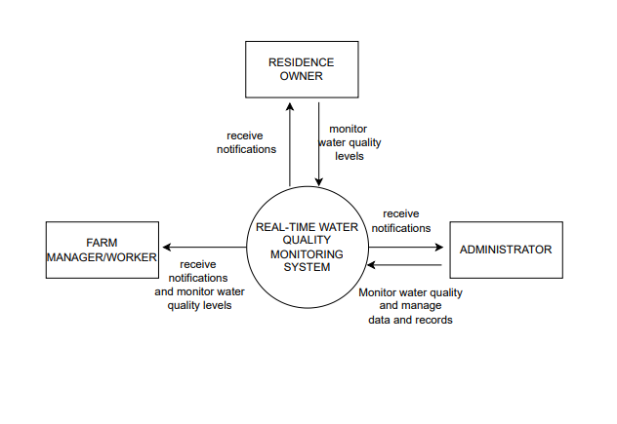

***Figure 2: Context Diagram***

### **3.3.2 DATAFLOW DIAGRAM**

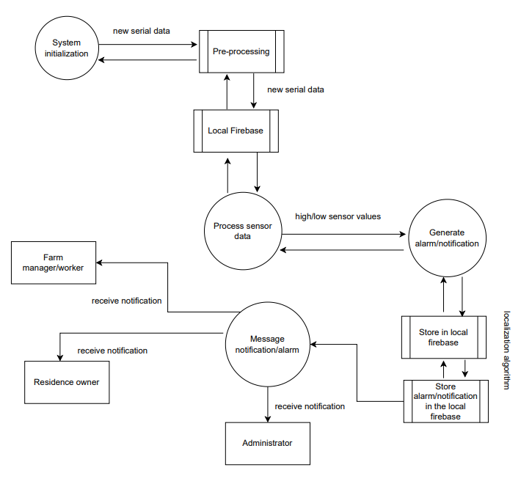

***Figure 3: Dataflow Diagram***

### **3.3.3 USE CASE DIAGRAM**

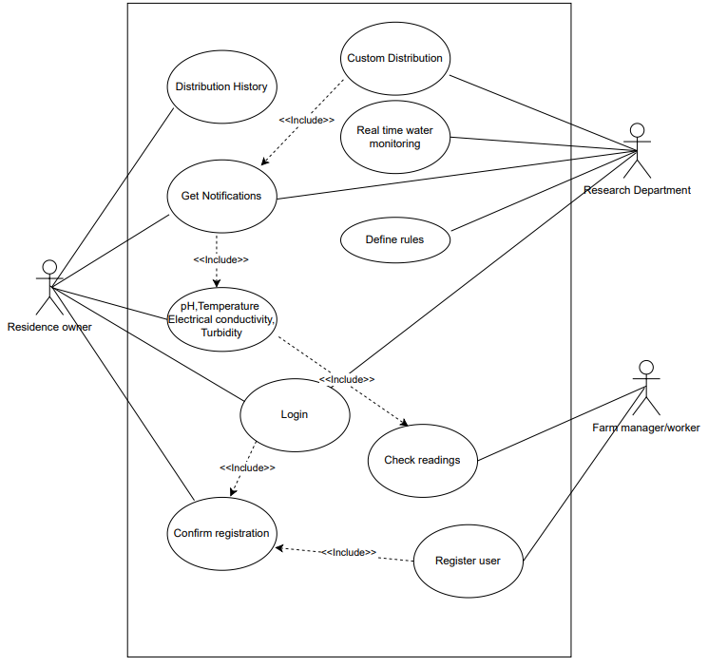

***Figure 4: Use case diagram***

# **CHAPTER FOUR: SYSTEM IMPLEMENTATION AND DEPLOYMENT**

## **4.0 INTRODUCTION**

In this chapter, we embark on the crucial phase of system implementation and deployment, where the conceptual framework and designs crafted in prior stages come to life. Here, we transition from theory to practice, detailing the concrete steps involved in bringing the envisioned system to realization. Through careful planning, execution, and integration of technological components, this chapter serves as a roadmap, guiding readers through the practical aspects of transforming ideas into functional reality, ultimately paving the way for the realization of our project's objectives.

## **4.1 SYSTEM DESCRIPTION**

The real-time water quality monitoring system consists of sensors placed within the water system, measuring parameters temperature and total dissolved solids (TDS). Data collected by these sensors are processed by a central unit, then transmitted to a server for real-time monitoring. Users access the system via desktop or mobile applications, which provide visualizations of the data, enabling stakeholders to make informed decisions regarding water management and public health.

## **4.1.1 HARDWARE ARCHITECTURE**

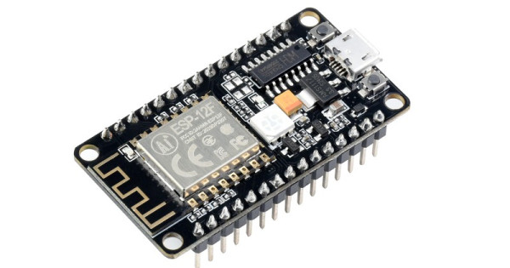

### **Figure a: NodeMCU esp8266**

The NodeMCU (Node MicroController Unit) is an open-source software and hardware development environment built around an inexpensive System-on-a-Chip (SoC) called the ESP8266. The ESP8266, designed and manufactured by Espressif Systems, contains the crucial elements of a computer: CPU, RAM, networking (WiFi), and even a modern operating system and SDK.

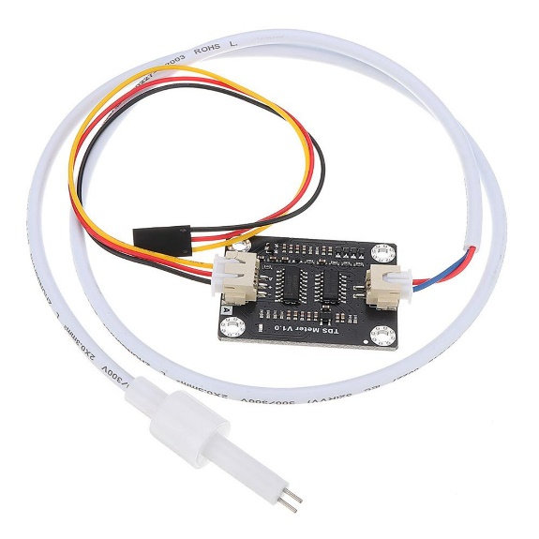

### **Figure b: TDS Sensor**

TDS (Total Dissolved Solids) indicates how many milligrams of soluble solids are dissolved in one liter of water. In general, the higher the TDS value, the more soluble solids are dissolved in water, and the less clean the water is. Therefore, the TDS value can be used as one reference point for reflecting the cleanliness of the water. This can be applied to domestic water, hydroponic and other fields of water quality testing and monitoring.

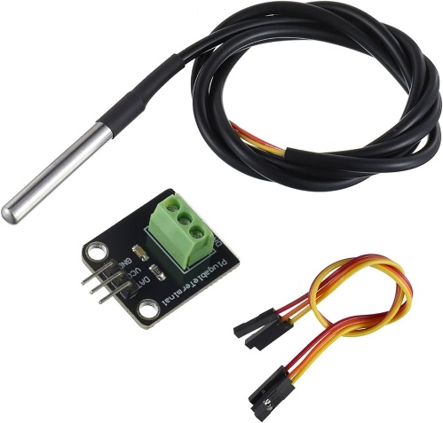

### **Figure c: Temperature sensor**

The DS18B20 is a 1-wire programmable Temperature sensor from maxim integrated. It is widely used to measure temperature in hard environments like in chemical solutions, mines or soil etc. The constriction of the sensor is rugged and also can be purchased with a waterproof option making the mounting process easy. It can measure a wide range of temperature from -55°C to +125° with a decent accuracy of ±5°C. Each sensor has a unique address and requires only one pin of the MCU to transfer data so it a very good choice for measuring temperature at multiple points without compromising much of your digital pins on the microcontroller.

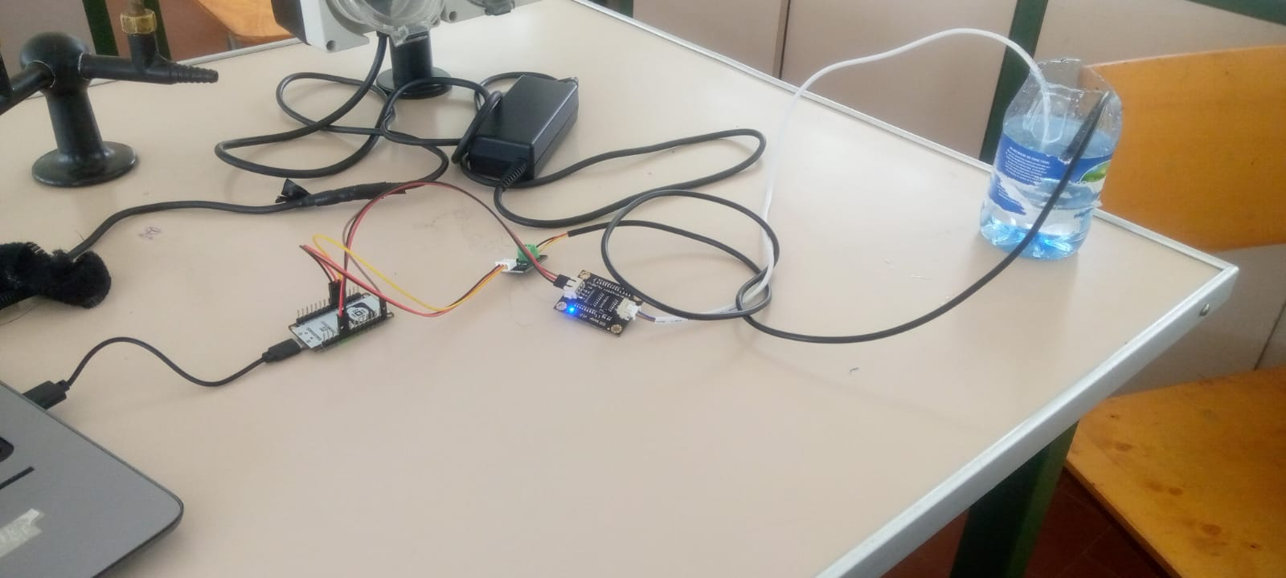

### **Figure d: Integration of all the devices**

## **4.1.2 USER INTERFACE DESIGN (WEB APPLICATION)**

The project records information on a platform known as Blynk. Blynk is a comprehensive software suite that enables the prototyping, deployment, and remote management of connected electronic devices at any scale.

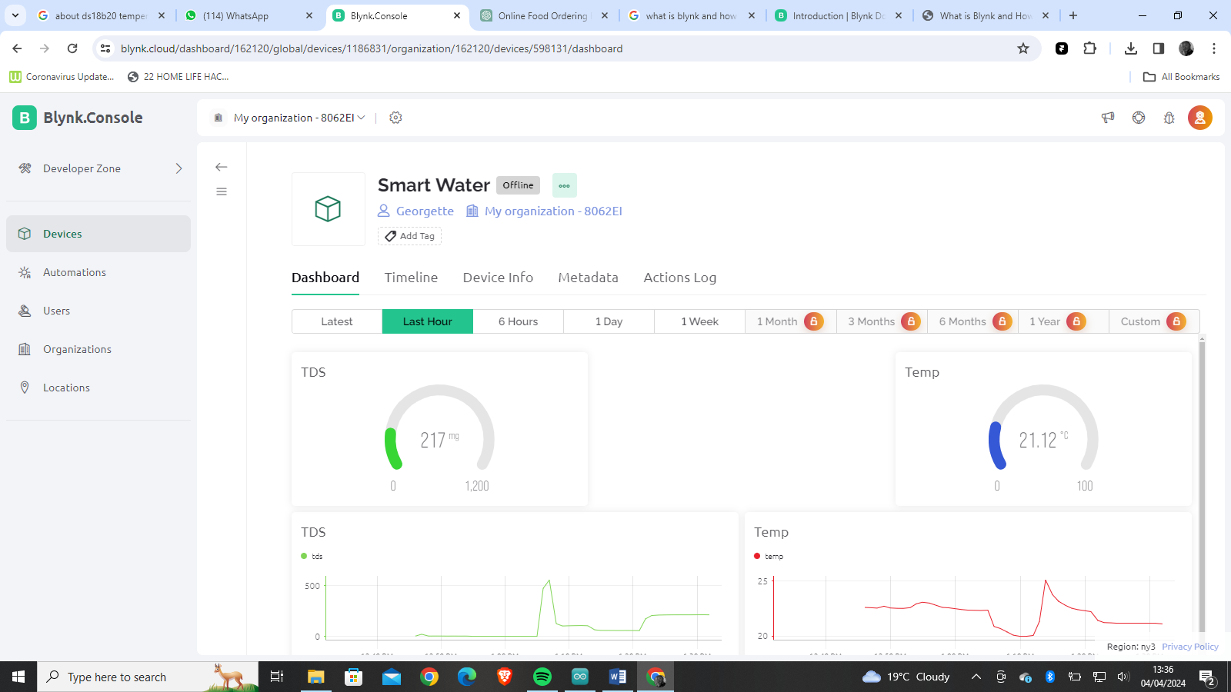

## **4.1.3 USER INTERFACE DESIGN (MOBILE APPLICATION)**

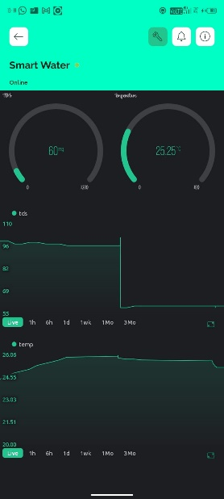 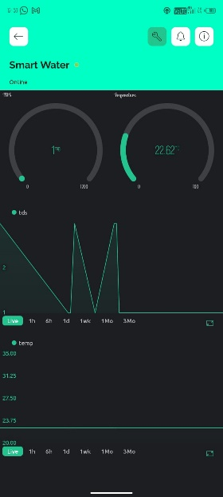

## **4.1.4 BACKEND DEVELOPMENT**

The project code is run on the Arduino IDE that contains a text editor for writing code. It connects to the Arduino hardware to upload programs and communicate with them.

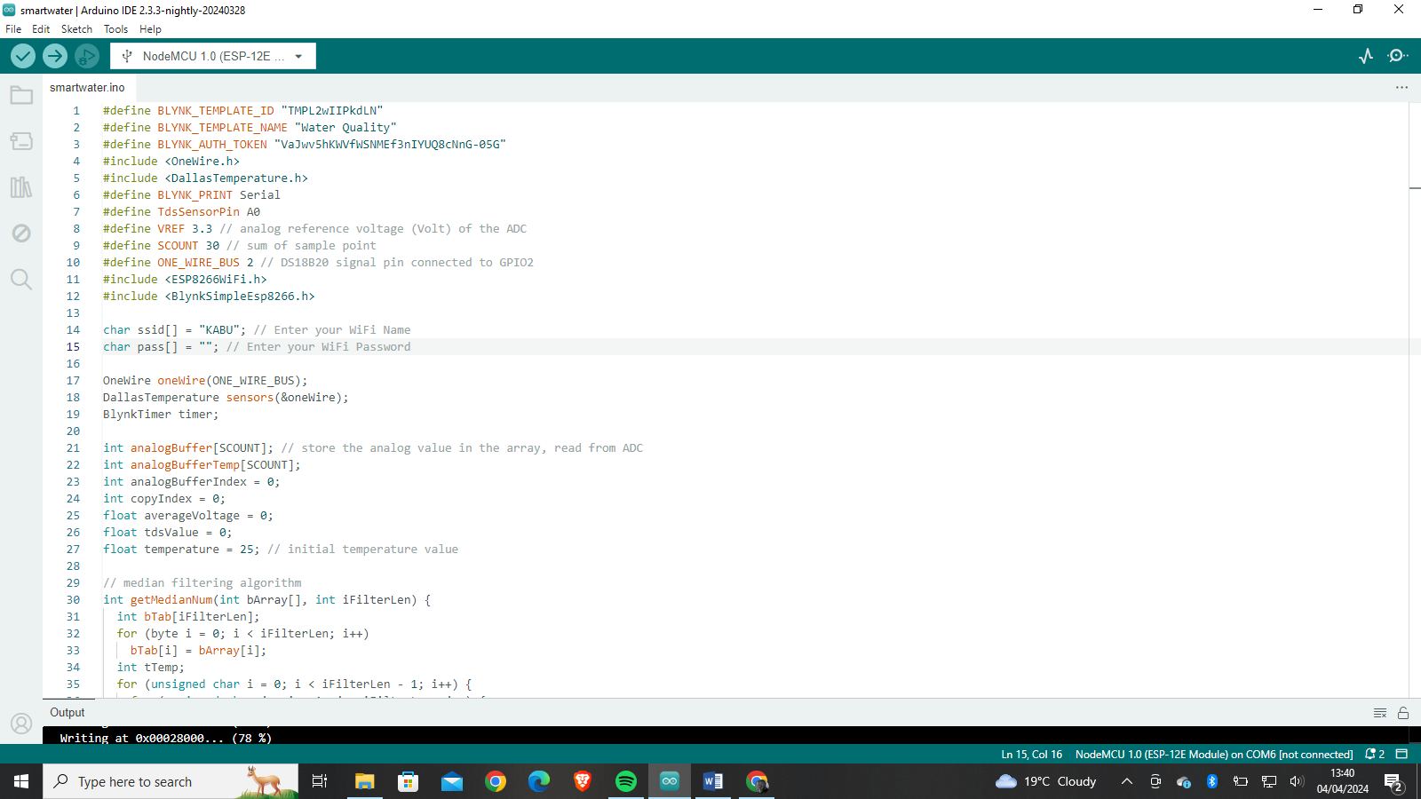

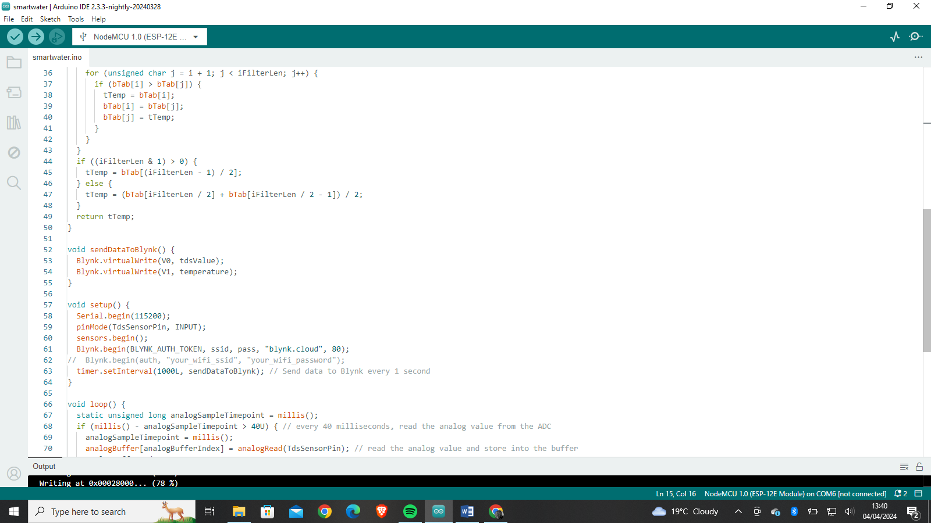

**CHAPTER FIVE: CONCLUSION AND RECOMMENDATION**

## **5.0 CONCLUSION**

In conclusion, the implementation of a real-time water quality monitoring system represents a significant advancement in ensuring the safety and sustainability of water resources. By harnessing cutting-edge technology and data-driven insights, this project not only enhances our ability to detect and address water quality issues promptly but also empowers stakeholders to make informed decisions regarding water management and public health.

## **5.1 RECOMMENDATION**

These recommendations offer essential guidance for improving a real-time water quality monitoring system.

Implement automated data analysis techniques to detect trends, anomalies and potential water quality issues in real-time, enabling prompt response and intervention

Foster collaboration with relevant agencies, research institutions and community groups to share data, expertise and resources facilitating more holistic approach to water quality management.

Establish mechanisms for gathering feedback from end users and stakeholders to identify areas for improvement and innovation, driving continuous iterative refinement of the monitoring system.

## **5.2 FUTURE IDEAS**

1. **Integration of Artificial Intelligence (AI)-** Explore the incorporation of AI algorithms to analyze data patterns and predict potential water quality issues, enabling proactive management and intervention
2. **Multi-parameter sensors-** Invest in multi-parameter sensors capable of measuring multiple water quality simultaneously, reducing the number of sensors required and improving efficiency
3. **Community Education**- Develop educational programs and outreach initiatives to raise awareness about water quality issues and empower communities to take active roles in water resource management.

# **REFERENCES**

Rodríguez-Narváez, O. M., Peralta‐Hernández, J. M., Goonetilleke, A., & Bandala, E. R. (2017). Treatment technologies for emerging contaminants in water: A review. *Chemical Engineering Journal*, *323*, pg 361–380. 

Hakimi, I. M., & Jamil, Z. (2021). Development of water quality monitoring device using Arduino UNO. *IOP Conference Series: Materials Science and Engineering*, *1144*(1), pg 64-67.

Pasika, S., & Gandla, S. T. (2020). Smart water quality monitoring system with cost-effective using IoT. *Heliyon (Londen)*, *6*(7), pg 96-109

Koki, I. B., Low, K. H., Juahir, H., Zali, M. A., Azid, A., & Zain, S. M. (2018). Consumption of water from ex-mining ponds in Klang Valley and Melaka, Malaysia: A health risk study. *Chemosphere*, *195*, pg 641–652

Soni, K., Waghela, D., Shah, R., & Mohan, M. (2018). Smart Well Monitoring System. *2018 International Conference on Smart City and Emerging Technology (ICSCET)*, *121(3)* pg 218-231

# **APPENDICES**

## **RESEARCH QUESTIONNAIRE**

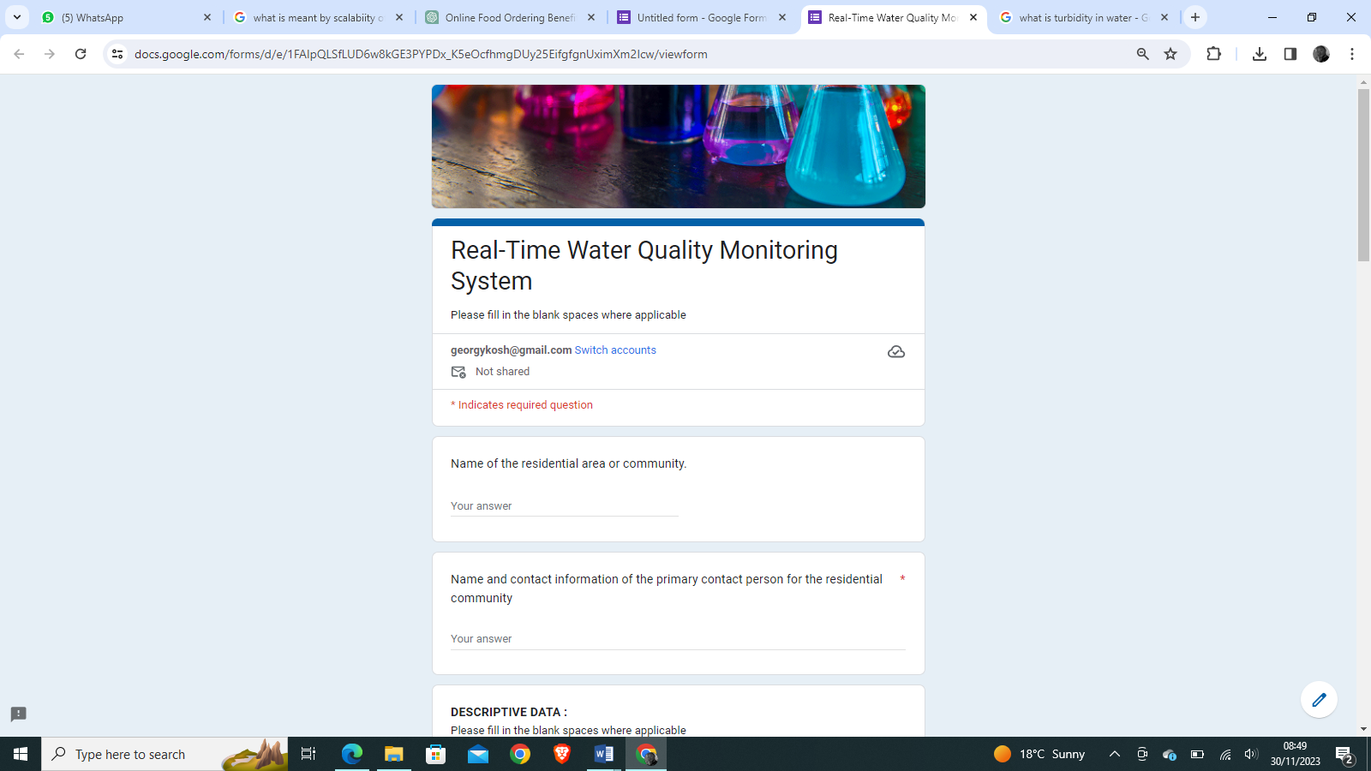

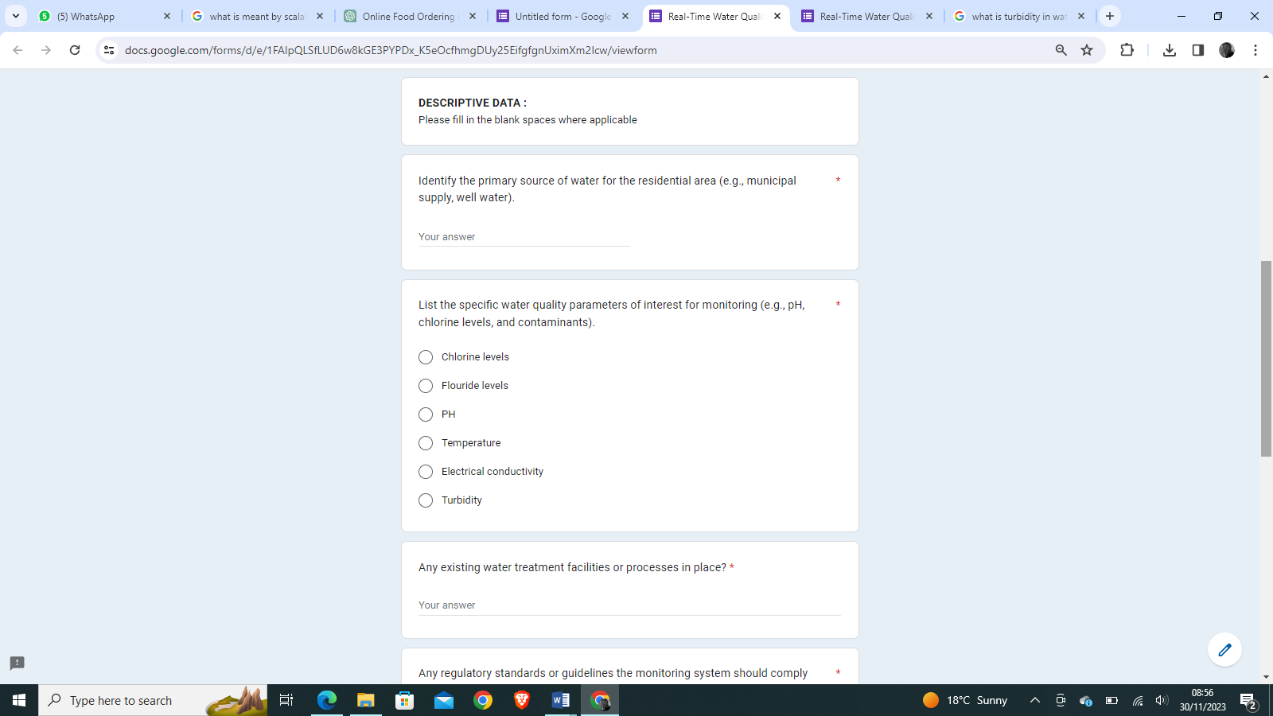

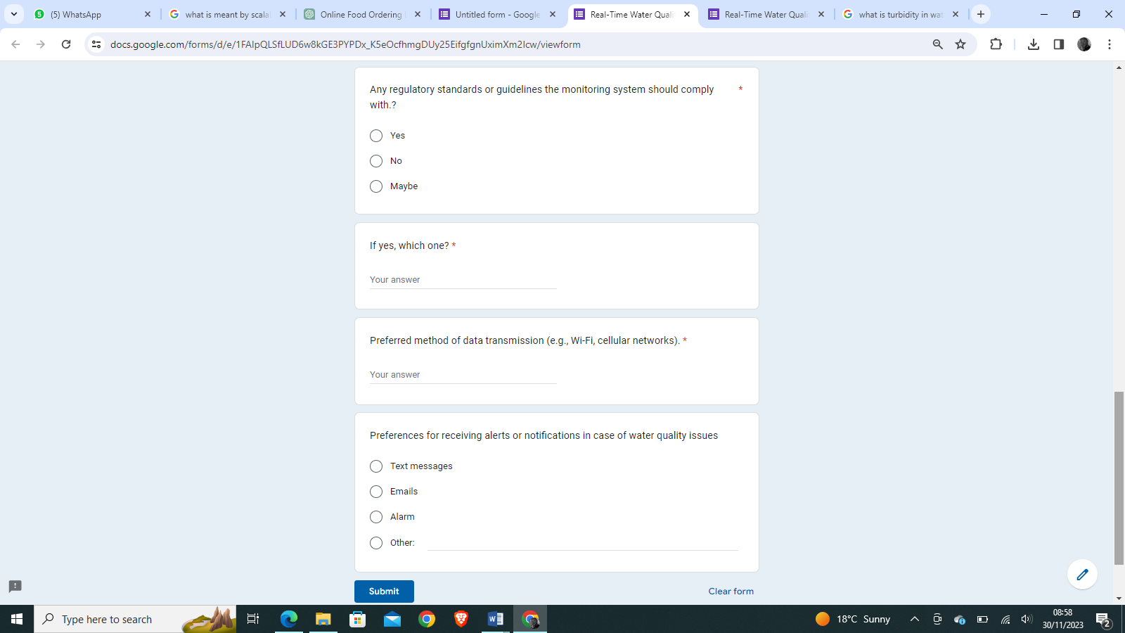

## **WORKPLAN**

|  |  |  |  |
| --- | --- | --- | --- |
|  | Month | Week | Description of work |
| 1 | September | Week 1-2 | Project kickoff:  Define project objectives |
| Week 3-4 | Engagement and requirement gathering:  Engage with residential community representatives.  Gather detailed requirements for water quality parameters and user preferences |
| 2 | October | Week 1-4 | System Design and Architecture:  Design the overall system architecture.  Identify IoT devices, sensors, and data transmission methods. |
| 3 | November | Week 1-4 | Device Procurement:  Finalize specifications of the IoT devices and sensors.  Establish the cost measures and purchase locations |

## **PROJECT BUDGET**

|  |  |  |
| --- | --- | --- |
| DESCRIPTION | UNIT PRICE (KSH) | TOTAL |
| Temperature Sensor (DS18B20) | 250 | 250 |
| PH sensor (SEN0161) | 1100 | 1100 |
| TDS Sensor (DFR0300) | 2500 | 2500 |
| Turbidity Sensor (SEN0189) | 1500 | 1500 |
| NodeMCU | 800 | 800 |
| Mobile phone | 10000 | 10000 |
| **TOTAL** |  | **=16,150** |